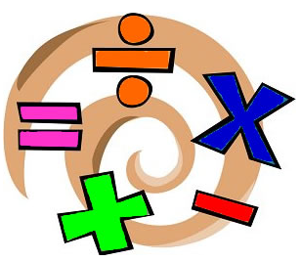

Kensington Primary School
Year 1
Maths Curriculum

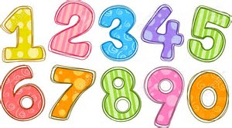
Number
- Count reliably to 100. (Forwards and backwards, from any given number).
- Count on and back in 1s, 2s, 5s and 10s from any given number to 100.
- Say the number that is one more and one less than a number to 100.
- Recognise odd and even numbers
- Write all numbers in words to 20.
- Distinguish between and use: ordinal and cardinal numbers

Addition and Subtraction
- Add and subtract 1-digit and 2-digit numbers to 20, including 0
- Add three 1-digit numbers.
- Recall all pairs of addition and subtraction to 20, including zero.
- Solve simple one-step problems that involve addition and subtraction using concrete objects, pictorial representations and missing number problems.
- Know the signs (+); (-) and (=).
- Solve a missing number problem, such as: 5 = 8 -___
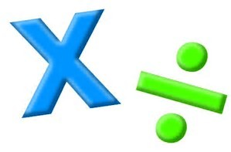
Multiplication and Division
- Recognise and write multiplication (x) and division symbols (÷).
- Solve one-step problems involving multiplication and division, by calculating the answer using concrete objects, pictorial representations and arrays.
- With support solve simple multiplication and division problems.
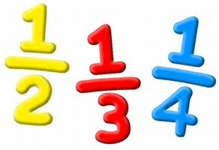
Fractions
- Recognise, find and name a half as one of two equal parts of an object, shape or quantity.
- Recognise, find and name a quarter as one of four equal parts of an object, shape or quantity.
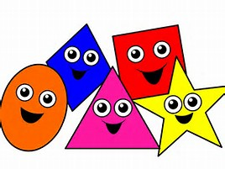
Geometry
- Recognise and name 2-D shapes: to include: rectangle (including squares), circle and triangle.
- Recognise and name 3-D shapes: to include cuboids (including cubes), pyramid and sphere.
- Describe position, directions and movements including whole, half, quarter and three-quarter turns.

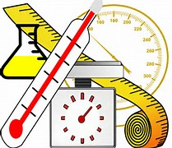
Measures
- Compare, describe and solve practical problems for:
Length and height (long/ short, longer/ shorter; tall/short; double/half)
Mass/ weight (heavy/ light, heavier than, lighter than)
Capacity and volume (full/ empty, more than, less than, half, half full, quarter)
Time (quicker, slower, earlier and later)
- Measure and begin to record the following:
Length and height
Mass/ weight
Capacity and volume
Time (hours, minutes, seconds)
- Recognise and know the value of different denominations of coins and notes (50p, 20p, 10p, 5p, 1p)
- Sequence events in chronological order using language (e.g. before, after, next, first, today, yesterday, tomorrow, morning, afternoon and evening)
- Recognise and use language of dates: days of the week, weeks, months and years
- Tell time: to hour and half past

