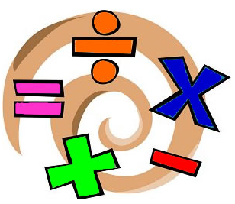

Kensington Primary School
Year 2
Maths Curriculum


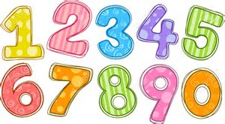
Number
- Count on in steps of 2, 3, 5 and 10 from any number.
- Recognise the place value of each digit in a two-digit number (tens and ones).
- Give 10 more or less than any number to 100.
- Use ˂ , ˃ and = signs to compare and order numbers to 100.
- Read and write numbers to 100 in numerals and words.
- Order, read and write numbers in increasing and decreasing value.
- Use number facts and place value to solve number facts
- Recognise odd and even numbers.
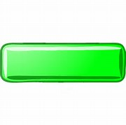
- Distinguish between and use: ordinal and cardinal numbers.


Addition and Subtraction
- Recall and use addition and subtraction facts to 20 fluently.
- Add and subtract mentally up to two-digit numbers using concrete objects and pictorial representations.
- Add and subtract up to two-digit numbers using written methods including columnar addition (without carrying or borrowing).
- Add and subtract mentally: a two-digit number and ones, a two-digit number and tens, 2 two-digit numbers; and 3 one-digit numbers.
- Use subtraction in ‘take away’ and ‘find the difference’ problems.
- Recognise that addition can be done in any order but subtraction cannot.
- Understand commutatively in relation to addition, subtraction, multiplication and division.
- Solve addition and subtraction word problems with up to 2-digits.
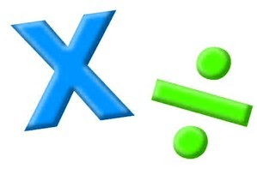
Multiplication and Division
- Recall multiplication and division facts for the 2, 5 and 10 times tables.
- Use x, ÷ and = signs to read and write mathematical statements
Recognise that multiplication can be done in any order but division cannot.
- Solve word problems involving multiplication and division, using materials, arrays, repeated addition, mental methods, and multiplication and division facts, including problems in contexts.
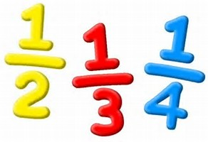

Fractions
- Name the fractions ⅓, ¼, 2/4 and ¾ and find values of shapes; lengths and number.
- Count in halves and quarters to 10.
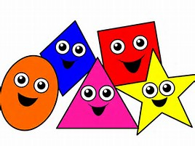
Geometry
- Recognise and name common 2D and 3D shapes.
- Identify and describe properties of 2D shapes, including the number of sides and line symmetry in a vertical line.
- Identify and describe properties of polygons and non-polygons.
- Describe properties of 2D and 3D shapes, including the number of edges, vertices and faces.
- Identify 2D shapes on the surface of 3D shapes.
- Compare and sort common 2D and 3D shapes.
- Order and arrange combinations of mathematical objects in patterns and sequences.
- Use mathematical vocabulary to describe position, direction and movement, including movement in a straight line and distinguishing between rotation as a turn and in terms of right angles for quarter, half and three-quarter turns (clockwise and anti-clockwise).
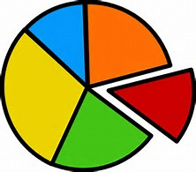
Statistics
- Interpret and construct simple pictograms, tally charts, block diagrams and simple tables.
- Ask and answer simple questions by counting the number of objects in each category and sorting the categories by quantity.
- Ask and answer questions about totalling and comparing categorical data.
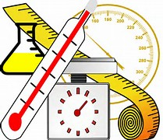
Measures
- Choose and use appropriate standard units to estimate and measure using rulers, scales, thermometers and measuring vessels,
Length/height (m, cm) in any direction
Mass (kg, g)
Temperature (°C)
Capacity (l, ml) to the nearest appropriate unit
- Compare and order lengths, mass, volume/capacity and record results using ˂,˃ and =.
- Read scales to the nearest numbered unit.
- Recognise and use symbols for pounds (£) and pence (p); combine amounts to make a particular value.
- Find different combinations of coins that equal the same amount of money.
- Recognise and use the symbols and p when solving problems involving addition and subtraction of money.
- Estimate and measure using appropriate standard units, using appropriate measuring vessels, rulers and scales:
Height/length (m, cm)
Mass (kg, g)
Temperature (°C)
Volume and capacity (l, ml)
- Tell and write the time to 5 minutes (including quarter to and past).
- Recognise coins and notes of different values.
- Combine amounts to make values and match combinations of coins to amounts of money
- Add and subtract money of the same unit

