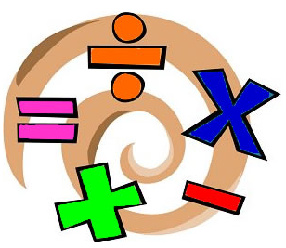

Kensington Primary School
Maths Mastery

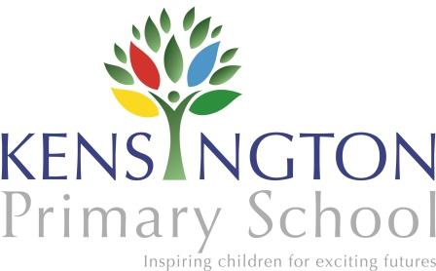

Mathematics is all around us and it underpins much of our daily lives and our future as individuals and collectively. At Kensington our aim is to ensure that all children have the best grounding in mathematics and that they are challenged regularly to grow in their love of mathematics.
Aims: At Kensington we actively aim to:
- Develop a fascination and love for investigating, problem solving and application of knowledge, in a variety of contexts.
- Provide a relevant, challenging and enjoyable mathematics curriculum for all pupils;
- Meet the requirements of the National Curriculum programmes of study;
- To enable all students to understand the value of mathematics in everyday situations;
- Raise standards and achievement levels in mathematics both independently and in co-operation with others.
- Ensure that all students know the times tables up to 12 by the end of Year 4.

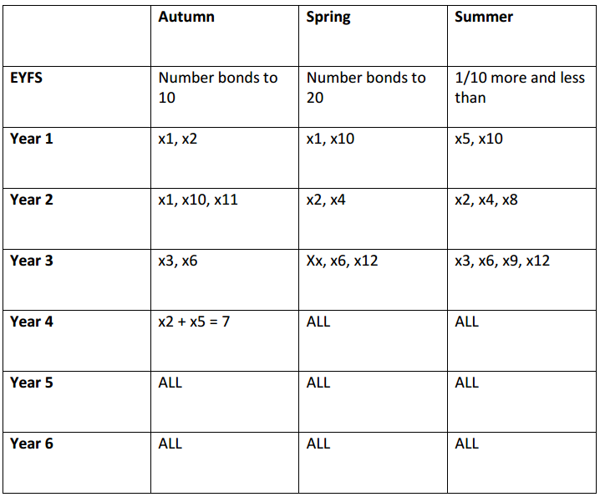
Times Table Map

20/20 and 144
When students in KS1 know all their number bonds they will be become a member of the 20/20 club (badges will be given out half termly in assembly).
When students in KS2 know all their times tables they will become a member of the 144 club (badges will be given out half termly in assembly).
NB: Students will be tested half termly to join the club and those already a member need to pass the test again to stay a member.
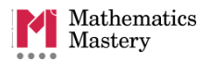
Maths Mastery

In September 2014 we launched a new Mathematics programme called Mathematics Mastery in Reception Classes. The programme has been extremely successful; therefore has been rolled out through Key Stage One and Year 3.
There are three key features of the primary programme and each of them are aimed at delivering pupils with a deep understanding of mathematics.
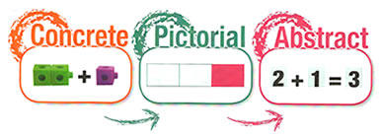
Children use concrete (objects) and pictorial representations (pictures), before moving to abstract symbols (numbers and signs).

Spring 2 Overview
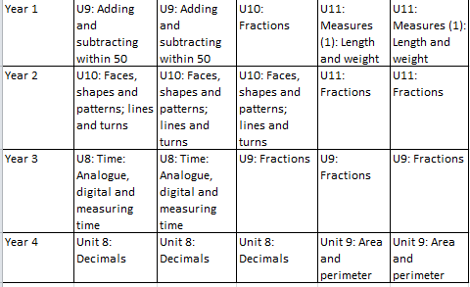

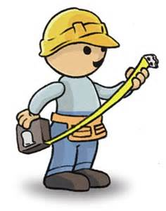
How can you support at home?
- Through play and use of language (compare/reason)
- Spend money! Encourage your child to count out the correct about of money needed and calculated the change. Work out a new price if things are in the sale and have a percentage off.
- Tell the time/measure time throughout the day.
- Identify shapes this can be on walks, traveling or around the home.
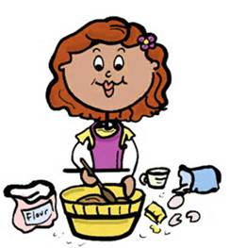
- Measure and estimate the height, weight and volume of objects around the home.

- Bake or cook with you child encourage them to half or double the recipe, work out the ratio to some ingredients to another and measure the ingredients.

Useful Websites

- http://www.bbc.co.uk/schools/websites/4_11/site/numeracy.shtml
- http://mathszone.co.uk/
- http://www.topmarks.co.uk
- http://www.crickweb.co.uk/ks2numeracy.html
- http://www.ictgames.com/resources.html

