Emotion coaching
At Kensington we use Emotion coaching to teach children better ways to manage behaviour. Emotion coaching is a method of supporting children in understanding and managing their emotions, helping them to recognise, name, and work through their feelings in a constructive way. Developed by psychologist John Gottman, emotion coaching is based on empathy, validation, and guidance, which helps children become more emotionally resilient and improves their ability to handle challenging situations.

Key Steps in Emotion Coaching:
Emotion coaching generally involves five main steps:

Be Aware of the Child’s Emotions: Recognise when a child is experiencing an emotion, even if it’s not explicitly expressed.
Connect with the Child: Show empathy by acknowledging the child’s feelings and communicating that you are there to listen.
Listen without Judgment: Avoid minimising or dismissing the child’s emotions; instead, provide a safe space for them to express themselves.
Label the Emotion: Help the child identify and name what they are feeling, which increases their emotional vocabulary and self-awareness.
Problem-Solve Together: Guide the child in understanding why they feel that way and discuss constructive ways to cope or address the situation.

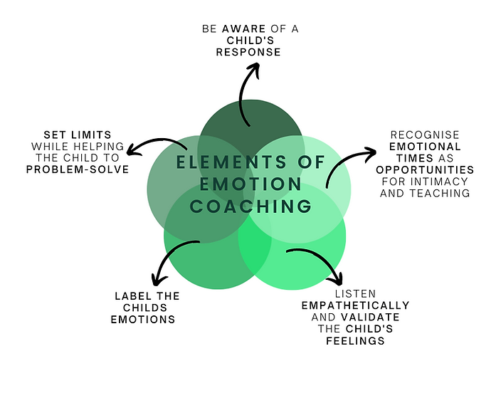
Why Emotion Coaching is Useful in Schools:
Emotion coaching has been found to offer several key benefits when applied in educational settings:

Improves Emotional Literacy: Children learn to recognise and express their emotions, which is crucial for developing social-emotional skills. Improved emotional literacy helps with self-regulation, especially in challenging or conflict-prone environments.

Reduces Behavioural Issues: By helping children manage emotions constructively, teachers can reduce the frequency and intensity of behavioural outbursts. Students who feel heard and understood are less likely to act out due to frustration or anger.

Strengthens Teacher-Student Relationships: Emotion coaching fosters trust and respect between teachers and students, creating a supportive classroom atmosphere. When students feel that teachers genuinely care about their feelings, they are more likely to engage and participate in the learning process.

Promotes Resilience and Problem-Solving: Students learn coping strategies and are better equipped to handle setbacks and challenges. Emotionally resilient children are more adaptable and less likely to be overwhelmed by stress or peer conflict.
Supports a Positive School Climate: When emotion coaching becomes part of the school culture, it sets a tone of empathy, respect, and understanding. This positive climate encourages collaboration and reduces bullying, fostering a sense of community.

Improves Academic Performance: Emotionally supported students are more focused, motivated, and ready to learn. Research shows that students with strong emotional and social skills tend to perform better academically.
What is Emotion Coaching?-link for further information

