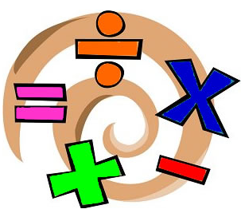

Kensington Primary School
EYFS
Maths Curriculum
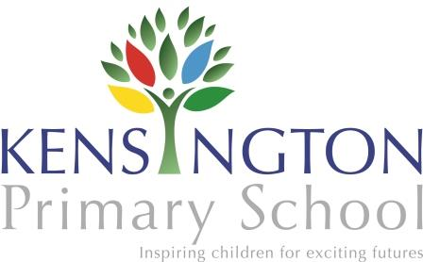

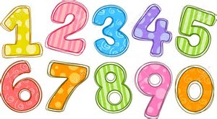
Numbers

- Count reliably with numbers from one to 20,
place them in order and say which number is one more
or one less than a given number.
- Use quantities and objects, they add and subtract two single-digit numbers and count on or back to find the answer.
- Solve problems, including doubling, halving and sharing.

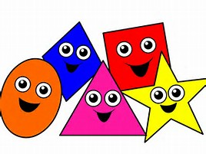
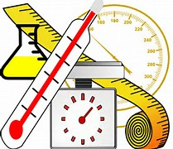

Shape, Space and Measure

- Use everyday language to talk about size, weight, capacity, position, distance, time and money to compare quantities and objects and to solve problems.
- Recognise, create and describe patterns.
- Explore characteristics of everyday objects and shapes and use mathematical language to describe them.

